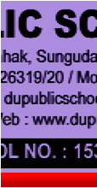

2021-2022

Annual planner
A
u
P
a
g
a

AFFILIATION NO: 1530179

SUJATA MOHAPATRA
Principal
DU PUBLIC S HOOL
C
CHANDIKHOL,SUNGUDA, JAJPUR,ODISHA

DU PUBLIC SCHOOL (SCHOOL NO. 15357)
) A
NNUAL PE
DAGOGIC
L PLAN

WWW.dupuiblicschool.com
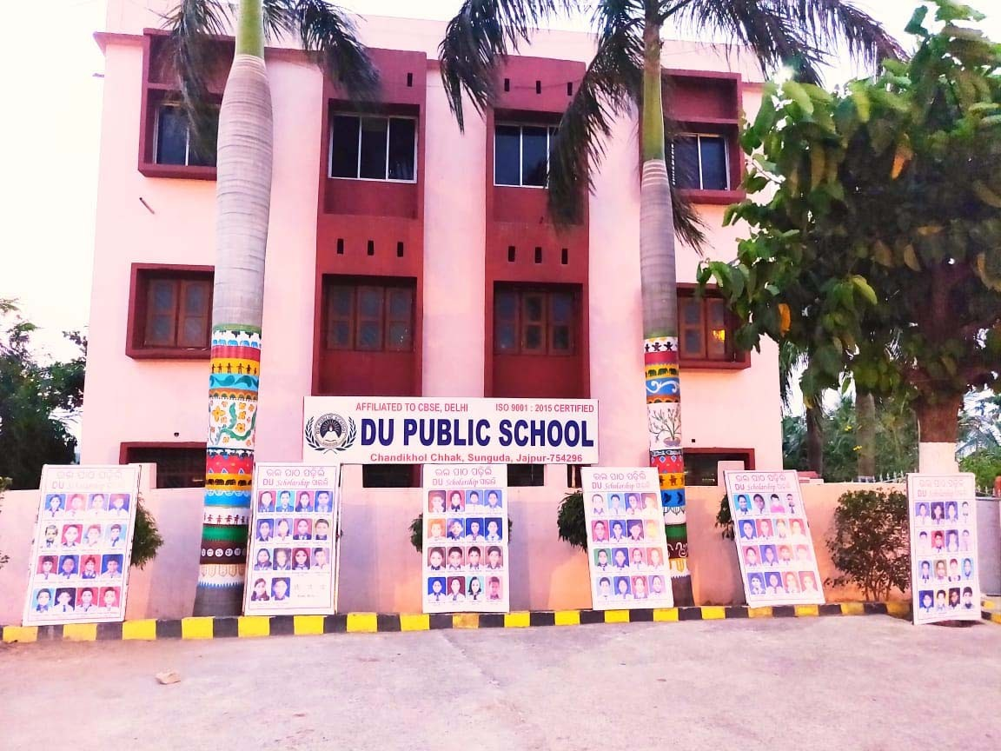
Travel on NH-16 from Cuttack to Cuttack. Daitari to paradeep Midpoint is the Chandikhole Square Situated Our school situated there “Pursuit of Excellence” is the motto of the school whether in the fields of academics, sports, arts or music.

SCHOOL INFORMATION
Sr.  No. | Particulars
1 | Total rooms – 50
2 | Separate hostel Boys and Girls – 2
3 | Principal Office-1 , 27' X 20'
4 | Other rooms – 9 , 20’ X 16’ (Management room, A.O. office, Store room, Staff room, Office, Conference hall, M I room, Activity Hall )
5 | Labs – 9 ,
 | Physics Lab - | 25’ X 18’
 | Chemistry Lab - | 30’ X 18’
 | Biology Lab - | 25’ X 18’
 | Composite science lab - 25’ X 18’
 | Computer Lab- | 30’ X 20’
 | Math Lab – 25’ x 18’
6 | Library – 1 , 60’ X 28’
7 | Art & Craft Room – 1 , 25’ X 18’
8 | School Transport – Total 06 Buses are available for day scholar students.
10 | Electricity arrangements – TPCL approved admissible voltage – 11KV .
11 | Total Number of students – 628
12 | Total number of teaching staff – 32
13 | Non Teaching Staff – 12
16 | Cemented overhead water tank and SINTEX TANK is available with submersible motor in both the block.
17 | Total 04 large size water filters are installed for drinking water.
18 | Total AC installed in school campus- 10 (of different capacity).
19 | Total Bathrooms- 32

Vision
To prepare dynamic and caring citizens of tomorrow, to meet the challenges of a global society, while retaining their traditional values.

Mission
To be a centre for excellence in education which, in keeping with the rich heritage of India, will stress on the simultaneous development of body, mind and spirit, and endeavour to create compassionate, responsible and innovative global citizens, committed to the development of India and the world.

Motto

“Be Your Own Light” The students at The Heritage are encouraged to explore, reach out, and seek answers for themselves. The teachers are encouraged to innovate, guide and, most importantly, become learners first.

ETHOS

DU Public School is a co-educational school, established to make children well-rounded and self- dependent individuals; the school has been constructed on a sprawling 10 acres campus with splendid infrastructural facilities in the tranquil and pollution free environment.
The entire gamut of activities in DU Public School reflects its objects of nurturing young children and making them responsible adults who can make a positive contribution to the world. A comprehensive academic and co-curricular programme, experienced faculty members, personal attention & care, state-of-the-art infrastructure collectively ensure that the education a child receives at DU Public School is holistic and truly.

Details of stakeholders

Stakeholder s | MethodsofCommunication | Ways of Involvement
Parents | - Social Media  - Print Media  - Calling  - SMS | - Parent’s Meeting  - Parent’s Orientation Programs  - Activities
Teaching Staff | - Print Media  - Social Media  - Meetings | - Personal Meetings  - Teacher Training Workshops
Other Staff | - Meetings  - Circulars | - Activities
School Managing Committee | - Meetings & Circulars | - Weekly Meetings With Staff  - Guidance And Controlling
Board | - Regular CBSE Circulars | - Application of Rules And Regulations Updated On CBSE Website
Media | - News Papers  - Social Media | - Achievements and Activities published in newspapers and updated on school’s Facebook page

Consultations and discussions held for preparing the Annual Pedagogical Plan (APP)

Name |  | Designation | Role in PPC
Mrs Sujata Mohapatra |  | Principal | To guide committee members how to prepare APP
Mrs. Rajashree Mohapatra |  | Vice Principal | Provide all the data related to Academic session
Mr. Nalinikanta Mudulki |  | Activity In charge | She provide all the data related to Co- curricular activities
Mrs. Gouri Sutar |  | Exam Co-coordinator | To collect all the data from the members and guide them time to  time.
Mr. Satya Priya Sahoo |  | Assistant Exam Controller | Provide all the data related to Academic session
Ms Barsha Rout |  | Science Department | Volunteer
Mrs. Rina Sahoo |  | H.O.D of English Department | Volunteer
Ms. Monalisha Nayak |  | H.O.D of Mathematics Department | Volunteer
Ms. Bindurekha Mallick |  | H.O.D of Hindi Department | Volunteer
Meetings to develop APP
Date | Stakeholders Consulted
March 2021 | Management, Parents, Teachers and students
April 2022 | Teachers and Students

Goals to be achieved – Annual and long Term
- Goals set by CBSE board will be tried to be achieved eg. Directing the entire focus of all the school activities towards the school’s learning processes.
- Promoting innovative pedagogy.
- Ensuring joyful learning at all levels
- Ensuring proper in house training of teachers

Annual Goals

- Previously set strategies will be continued although wherever need felt, innovative strategies according to situations will also be introduced.

Strategies

LongTerm Goal | - Leading, guiding and supporting the teaching and learning processes.  - Ensuring school’s specific resources for teaching and learning.
Strategies | - The best strategies ever used by any institution will be used.  - Extra remedial classes to improve academic performance  - School resources will be developed

School Culture

Aims and Objective
DU PUBLIC SCHOOLis about the spirit, morals and ethics of our nation blended with futuristic vision to impart quality education.

Aims and Objective:
- To provide education that nurtures traditions or our culture and also prepares for future competitions and challenges.
- To impart quality education based on modern and scientific technology.
- To foster the pursuit of excellence through our “Motto” Education Par Excellence.
- To provide a congenial atmosphere to all the students without any discrimination of caste, colour or creed.
- To develop the personality of child through holistic approach of self-discipline, tolerance, sportsmanship and dignity of labor by lying stress on emotional, intellectual, mental, physical, social and spiritual growth.

School Session
The School session is set within the framework of the Central Board of Secondary Education, New Delhi. School observes the Academic Session from April to March.

Curriculum
The school curriculum is based on the national pattern of education and designed as per the guidelines of C.B.S.E., New Delhi. The school holds classes from Nursery up to Senior Secondary stage of education with English as the medium of instruction. General Knowledge form an essential part of the school curriculum. Children are imparted quality education with the help of computer-based programmed lessons and other audio-visual media. To maintain an ideal standard, ratio between teacher and student is kept within the limits.
Timing to Meet the Principal
- Parents can meet the principal on all working days between 11:00am to 1:00pm.
- Kindly call the School Office and can fix up an appointment.
- Parents cannot meet the Teachers during School hours as it will disturb the teaching learning process.
- Parents can meet the teachers during PTM’s only.

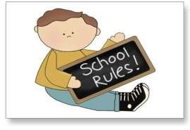

School Rules
- A student should carry his / her Almanac to school every day. It must have his / her photograph with complete information duly signed by parents / guardians.
- Students should reach the school at least 5 minutes before the bell timing.
- In case the child is being picked up by a person other than the Parent / Nominee, a prior written permission must be taken from school authority.
- Students who come to school in the care of helpers should never leave before the helper arrives. Helpers must carry ID cards. The loss of an I-card must be reported to the school immediately. In case of any delay, they should report to the school office.
- Students should refrain from carrying valuable items to school. Although every care will be taken of the student's property, the school will not be responsible for any theft or loss of the same.
- Any kind of damage done by the student to the school property within the school premises must be reported to the Principal. Damage of any kind is subject to a fine or payment for replacement / repairs.
- School management reserves the right to suspend / expel students whose conduct is harmful to the other students or to the school.
- Students should greet their seniors and teachers and give them due respect at all times. Bullying and inappropriate language is not allowed in the school.
- The students are to walk smartly in a queue and maintain silence whenever they move about in the corridors. They must also ensure that they keep to the left while walking in the corridors or on the stairs.
- Every student must have a minimum of 90% attendance to be promoted to the next class (unless medically advised to take rest).
- Once a child has come to the school, he / she should not be asked to come home on half day leave or leave for any period. In case of any emergency, the parent / guardian may collect the child from the school personally.
- Students should get the notes, circulars signed by their parents / guardians and return them to the class teachers for online and offline classes.
- No student shall indulge in any of the following practices, namely-
  - Disfiguring or otherwise damaging any school property.
  - Rowdy and rude behaviour.
  - Use of violence in any form.
  - Casteism, communalism or the practice of untouchability.
- No books other than text books should be brought to the school.
- Bringing electronic gadgets like cell phones, cameras etc., is strictly forbidden.
- Use of hair shaping gel is strictly prohibited.

TIFFIN SCHEDULE
To ensure a healthy balanced diet for proper growth and development of a child, the school has planned out a Tiffin schedule as given below.

TIFFIN SCHEDULE
Monday | Protein Day | Paneer, Dry Dal, Cheese, Sprouted Pulses, Cereals, Soya Nuggets, Roti, Parantha etc.
Tuesday | Green Veg Day | Any Seasonal Green Vegetable with compliments like Parantha, Puri etc.
Wednesday | Green Veg Day & Fruit Day | Any seasonal green vegetable with compliments like Parantha, Puri etc and any seasonal fruit.
Thursday | Fermented Day | Idli, Dhokla, Chila, Uttpam or Sandwitch with Fresh Vegetable filling, mint chutney, Filling or Sauce.
Friday | Fried Day | Cutlets, Bondas, Paranthas, Pakoras, Bread Roll, French Fries etc.
Saturday | Favourite Dish Day | Children can bring food of their own choice.

- The school seeks whole hearted cooperation of the parents in following the Tiffin schedule.
- Junk food is discouraged in the school.
CLASS: I to V (Monday to
Wednesday) CLASS: VI to XII (Thursday to Saturday)
- Prayer ( Daily ) 1. Prayer ( Daily )
- Thought ( Daily ) 2. Thought ( Daily )
- Pledge Monday) 3. Pledge (Thursday)
- News ( Daily ) 4. News ( Daily )
- G.K Quiz ( Daily ) 5. G.K Quiz ( Daily )
- Manners & Etiquettes Tips ( Monday) 6. Manners & Etiquettes Tips Saturday
- Speech ( Tuesday) 7. Speech ( Friday )
- English Vocabulary ( Daily ) 8. English Vocabulary ( Daily )
- National Anthem ( Daily ) 9. National Anthem ( Daily )

ACADEMIC RESOURCES AVAILABLE

Name of Resource  /s | Segment  Pre-primary/Primary/Sec/Sr.  Sec. | Usefulness
Smart Class | All three segments | Pre-primary, primary and senior secondary students learn everything easily with the help of smart classes
Language labs | Primary , secondary and senior secondary | Resources used in language lab are helpful in effective teaching and learning process
Science lab | Secondary and senior secondary level | Enhances mastery of science subject matter , develops scientific reasoning abilities , develops practical skills , develops understanding of nature of science , cultivate interest in science
Computers | Secondary and senior secondary level | It helps students to develop the knowledge about the current technology
Reference  Books (library) | Primary , secondary and senior secondary level | Students acquire knowledge
Library | All levels | To develop reading habits
ATL Tinkering Lab | Primary , secondary and senior secondary level | Build innovative ideas in students and surrounding school’s students about  Science and its applications.

